Lab: Sanitary Landfill

In this activity, students will design a sanitary landfill and bury various items in an effort to determine the relative degree of biodegradability among them.

During the 1950’s, a popular trend evolved called “throwaway living” that promised to cut down on tedious chores; today, the packaging material alone, amounts to over millions of tons of the waste. About 30% of all U.S. “garbage” is packaging, which is of little use to consumers and is typically thrown out after a product is purchased.
The U.S. produces more than 30 percent of the planet’s total waste, though it is home to only 4 percent of the world’s population. A Columbia University study estimates that Americans throw out about 2,555 pounds of materials per American every year. Those materials make up only 3 percent of all solid waste in America – the vast majority is generated by industrial processes such as mining, manufacturing and agriculture.
- The amount of municipal solid waste (garbage) produced in 1986 was over 91 million tons. The total generation of municipal solid waste (MSW) in 2017 was 267.8 million tons of MSW.
- In January 2018, China’s “National Sword” policy, began and banned the import of most plastics and other materials headed for that nation’s recycling processors. As a result, more plastics are now ending up in landfills, incinerators, or likely littering the environment as rising costs to haul away recyclable materials increasingly render the practice unprofitable.

Because we are running out of landfills, America now faces a big garbage problem. In the next 20 years over 3/4 of the landfills in the U.S. will shut down. Some will close because of health and safety regulations others because they’ve reached their capacity. Soon, there may not be many places for our trash to go. Other problems associated with landfills include type of waste we produce, waste that is not biodegradable, toxic or both.

TYPICAL PERCENTAGE OF MATERIALS THROWN OUT BY AMERICANS

- 26% Paper & cardboard
- 6% Yard trimmings
- 18% Food wastes
- 10% Metals
- 5% Glass
- 19% Plastics
- 11% Textiles & wood
- 3% Rubber & leather
- 2% Miscellaneous

~4.5 Pounds of Trash are produced Per Person Per Day

Sanitary Landfill
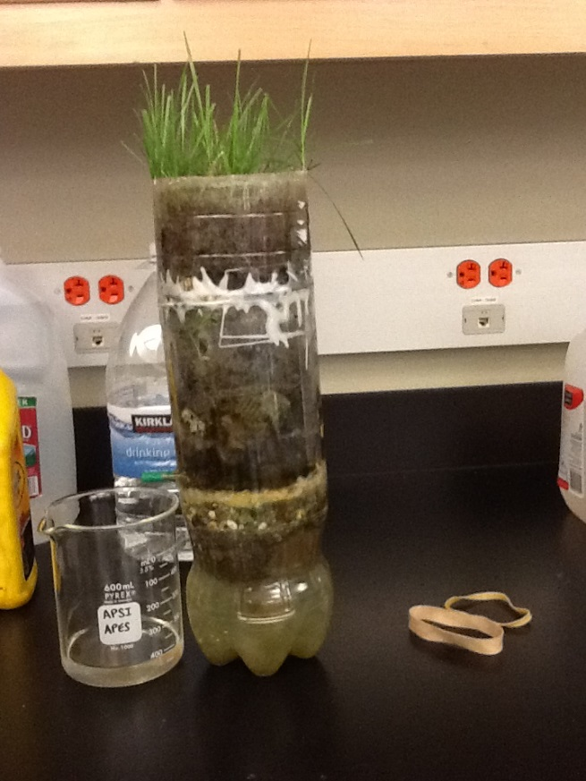
A modern sanitary landfill is designed to protect the environment from pollution and thus it is completely sealed. Water in a landfill dissolves pollutants out of the garbage, forming a solution known as leachate. To prevent this leachate from contaminating the groundwater, the landfill space is lined by a layer of clay covered by a heavy synthetic liner made out of plastic or rubber. The leachate is pumped up from the bottom of the landfill and stored in tanks prior to processing. When the landfill is full, it is covered with layers of clay, sand and topsoil and vegetation is planted to absorb the rainfall that can form leachate. In fact, some landfills are planned to provide recreational facilities, such as parks and playgrounds, when they are completely filled and secured. Anaerobic bacteria in a landfill, produce methane by decomposing wastes which is collected and used to fuel a turbine to generate electricity.
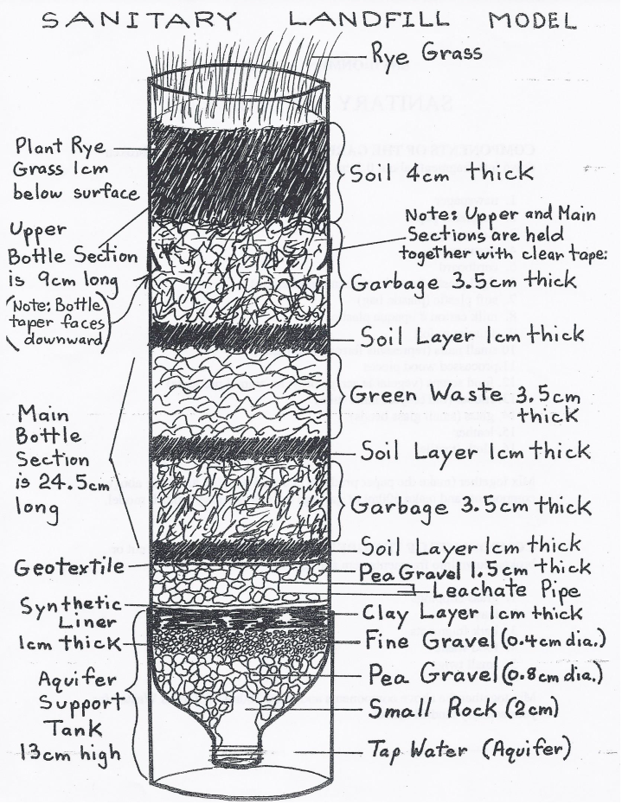
Pre-Lab:
- Go to: http://youtu.be/f2xD4uS40jg to see this lab in action!
- Read through the lab procedures
- Create your own data tables (one for MSW and GW & one for Water tests)
- Read the MSW and GW Materials list below…
- Gather materials needed and wanted for the lab

Materials: (pieces should be cut or broken down into fragments about 0.5 cm across)

2 – 2 Liter clear Plastic Bottles (cleaned, dried, and label removed)

MSW – 600mL *Note – 33% must be paper products
- newspaper
- magazine paper
- Xerox paper , piece of notebook paper
- tissue paper
- paper bag
- twine or string
- toilet paper
- wrapping paper
- cardboard
- aluminum foil
- small nails (represents ferrous iron metal)
- processed wood pieces (popsicle sticks, stirrers, furniture scraps)
- a painted wooden block or other painted wood item
- rubber (old bicycle inner tube, rubber bands)
- glass (small glass beads)
- pieces of aluminum soda can
- leather
- Cloth - Natural Fibers (Cotton, Linen, Wool, Silk)
- Cloth – Synthetic Fibers (Nylon, Rayon, Acetate, Acrylic, Polyester, Spandex)
- Styrofoam cup pieces
- starch packing “peanuts”
- a lock of hair or fur
- small bit of candle or piece of wax
- copper penny
- biodegradable plastic
- Code 1 plastic (PETE) polyethylene terephthalate, soft drink bottles, cooking oil bottles
- Code 2 plastic (HDPE) high density polyethylene, milk and water jugs, grocery bags, toys, liquid detergent bottles
- Code 3 plastic (PVC) polyvinyl chloride, flooring, shower curtains, house siding, and plumbing pipes
- Code 4 plastic (LDPE) low density polyethylene, bread bags, frozen food bags, cellophane wrap and grocery bags, 6-pack rings
- Code 5 plastic (PP) polypropylene, ketchup bottles, yogurt containers, margarine tubs, medicine bottles and long underwear.
- Code 6 plastic (PS) polystyrene, videocassette cases, compact disc jackets, foam coffee cups, knives, forks and spoons, grocery store meat trays, fast food sandwich containers

GW – 300mL
- grass clippings
- leaves
- bark fragments
- small twigs
- food waste (ex. an eggshell, nut shells, an unwrapped piece of candy bar, an orange or banana peel, bread, piece of hard candy, McDonald’s French fry)
- a dead invertebrate (ex. Spider, worm…) **Do NOT kill anything! It must already be dead!

OTHER Materials needed…

You need to provide per group:
- 2 – 2Liter clear plastic bottles
- Small, irregular shaped rock (fits into mouth of bottle without blocking it)
- Straws
- Aquarium sealant (1 squeeze Tube)
- MSW
- GW
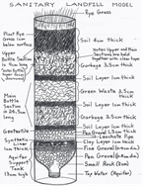

Provided by teacher
- 600mL / 300mL Beaker
- Scissors / box cutters
- Balances
- Water test kits
- Drill / Wood burning Tool
- Hammer
- Ruler
- Scoop Spoons (5)
- Pea Gravel
- Fine Gravel
- Clay
- Rolling pin for clay
- Thick plastic bags
- Permanent markers
- Geotextile
- Dirt
- Topsoil
- Rye Grass Seed
- Collecting Container (Cup)
- Cardboard tracing guide

You will have ONE – 2 hour block to work on this, make sure all your supplies are here on time!
Procedure:
- Decide what you will be burying in your landfill.
- RECORD the names/types of products to be buried in your landfill, in your data sheet. (MSW & GW)
  - Make sure to include at least one source of biodegradable plastic
- Develop a hypothesis about which items will biodegrade the fastest and which the slowest. RECORD
- Make 600mL of Municipal Solid Waste (MSW)
  - Make sure to cut or break all materials into tiny pieces (.5 - 1cm or less).
  - Quantitative data:
    - Mass each type of material
    - Estimate the % of each type of material (ex. Paper products should be ~ 33% of the total)
  - Qualitative Data:
    - Describe colors, hardness’s, thickness, etc… of your materials
    - Take photos
  - Mix all materials together in a cup or beaker. Set aside.
- Make 300ml of Green Waste from various plant materials. (GW)
  - Make sure to cut or break all materials into tiny pieces (.5 to 1cm or less).
  - Mix all plant matter together in a separate cup or beaker (do not mix the Green Waste with MSW)
  - Quantitative data:
    - Mass total amount of Green Waste
  - Qualitative Data:
    - Describe colors, hardness’s, thickness, etc… of your materials
    - Take photos
- Construct the framework of the Sanitary Landfill using two 2-liter clear plastic soda bottles. Tape the top section to the main section.
  - Bottle #1: Cut the base off. (Main section of landfill)
    - Keep the base – you will use it as a “cookie cutter” later to make the clay liner
    - Discard the plastic cap
  - Bottle #2:
    - Cut 1, leave some of the taper at the top of the bottle and cut. (discard)
    - Cut 2, Measure 13cm from the base and cut.
      - Base becomes the bottom of the model, the Aquifer
      - Middle section, turn over so taper side is down, becomes top section of model
- Fill your landfill…
  - Place a small irregularly shape rock inside the mouth of the upside down main bottle section. (The small rock should not easily be able to slide through the neck of the bottle, but at the same time, allow leachate to flow into the “underground aquifer.”)
  - Place the aquifer base on your table, place Bottle #1 upside down into the aquifer base with the rock in the opening
  - Now begin putting in the various components of the landfill starting with the pea gravel. Add a scoop of pea gravel to your landfill.
  - Add two scoops of fine gravel.
  - Shake landfill slightly to level out rocks, go to the sink and wash the gravel, twice. (Note: add water to landfill GENTLY so as not to disturb the gravel you have added)
    - FYI: Washing the gravel prevents dirt from getting into the aquifer in the model
  - Make the clay layer
    - Get a chunk of clay from the lab table and roll it into a ball
    - Using a 2 liter bottle filled with water, roll out the clay into a 1cm think layer
    - Use the base you cut off from Bottle #1 as the “cookie cutter” for your clay layer
    - On top of the fine gravel place the 1cm thick disk of clay, gently push it down into your landfill
    - Seal the clay to the inside of the bottle once it has been put into place by tracing your finger along the edges of the clay where the bottle and clay meet
  - Trace and Cut out a thick circular piece of plastic using the cleaned “cookie cutter” piece
    - Put the plastic disk onto the top of the clay layer
    - You can add 1 or 2 layers of plastic here – up to you (RECORD your reasoning for how many layers on your data sheet)
  - Burn a hole in the side of the bottle just above the plastic and clay liners using a wood burning tool that will just accommodate a 5 cm plastic soda straw. (SAFETY!)
    - Insert the plastic soda straw two centimeters into the side of the model
    - Seal the edges with aquarium sealant.
  - Add 1-2 scoops of pea gravel to surround the leachate pipe.
  - Place Bottle #2 taper side down into Bottle #1 and TAPE together.
    - (NOTE: Do NOT tape the aquifer to Bottle #1, you must have access to the aquifer)
  - Trace and Cut out a circular piece of geotextile using the cleaned “cookie cutter” piece
    - Insert the disk of Geotextile on top of the pea gravel
  - Add first a 1cm layer of dirt followed by a 3.5cm layer of MSW
  - Then add another layer of 1cm dirt followed by a 3.5cm layer of GW
  - Add another layer of 1cm dirt and another 3.5cm layer of MSW
  - Finish off the landfill with a final cover
    - Add 3cm of topsoil
    - Spread a layer of Rye Grass seeds
    - Add 1cm more of topsoil
  - Fill up your aquifer about ¾ the way full with water from the sink.
    - RECORD Quantitative and Qualitative Water Data (ex. Clarity, Turbidity, pH, Nitrates, TDS – Total Dissolved Solids, Phosphates)
  - Place a collecting container under your leachate straw to collect leachate from your landfill
  - You are now ready to have a rainfall event on your landfill.
    - Pour a cup of water on top of your landfill
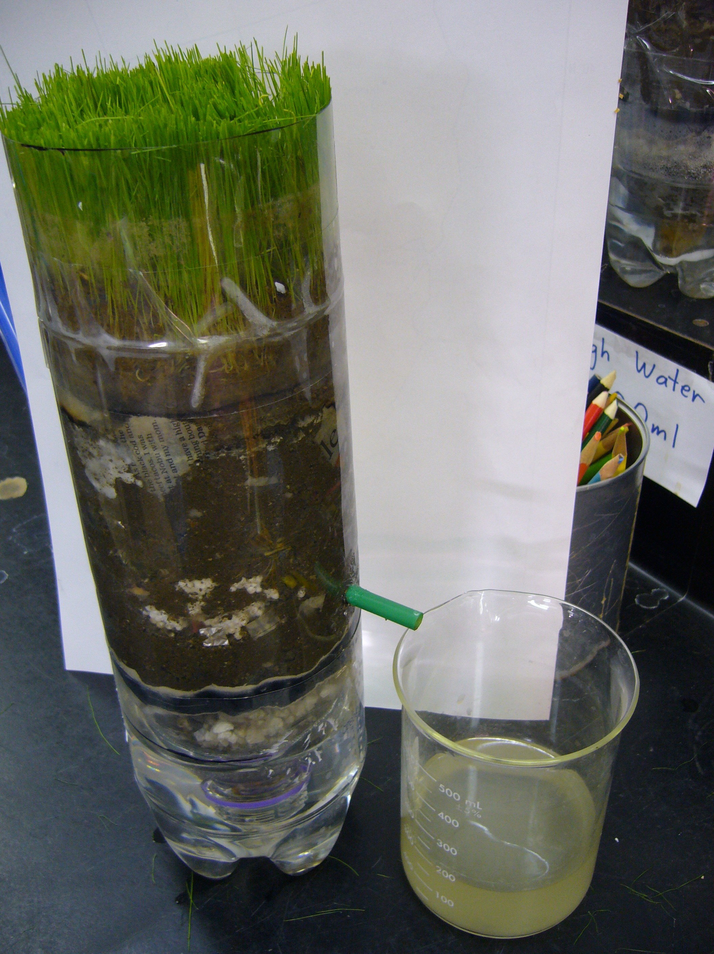
    - RECORD what you see
    - Pour a second cup of water on top of your landfill
  - Take a final photo of you and your completed landfill
- After 4-5 days your landfill golf course should be starting to grow!
    - Keep an eye on your golf course, you might have to “mow” it with scissors if it gets too long.
    - Every 2 weeks water your landfill with 300mL of water
- Once a week take data and RECORD.
- Each week include water tests for leachate water (Clarity, Turbidity, pH, Nitrates, TDS – Total Dissolved Solids, Phosphates)
- Aquifer water tests should only be done at the beginning and end of the lab.

The goal is to maintain the clarity of the underground aquifer!

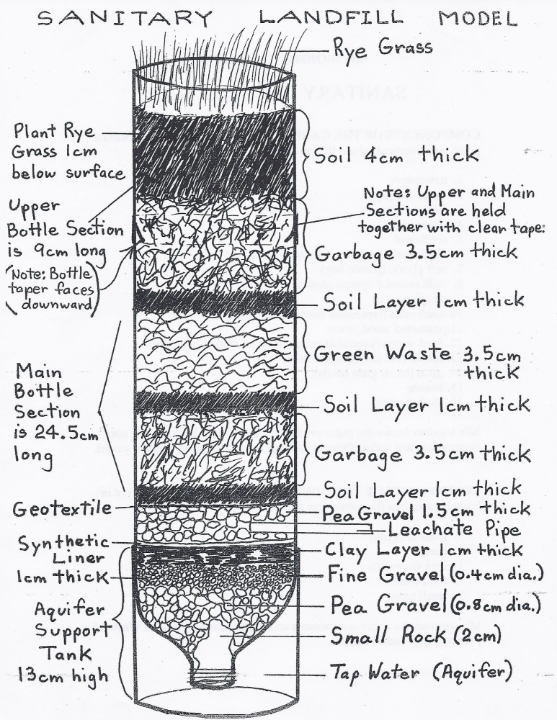

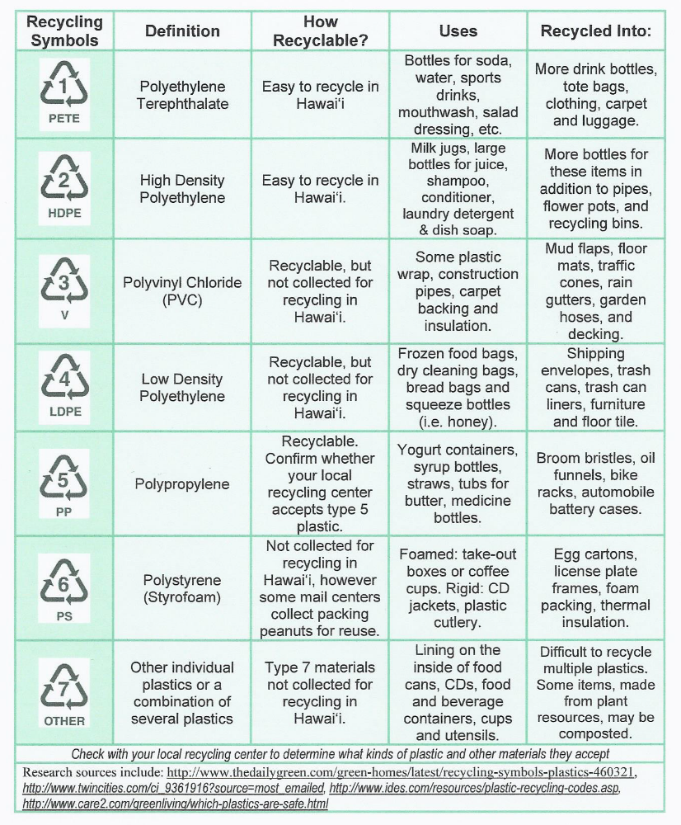

Make your own data table:
Example of a data table to get you started, yours should be more complete and inclusive…
 | General Appearance & Condition | Color | Texture | Fiber Strength | Mass
Paper & Cardboard

Plastic
Type: ______
Type: ______
Biodegradable Plastic
Metals

Wood

Glass

Natural Fibers
(Cotton, Linen, Wool, Silk)
Synthetic Fibers
(Nylon, Rayon, Acetate, Acrylic, Polyester, Spandex)
Rubber & Leather

GW:
Yard Waste, Food Waste, & Plant Material

Rate fiber strength as follows:
+ + + Original strength at start
+ + Starting to show signs of disintegration such as breaks or cuts of the thinner fibers in your sample.
+ Very weak - but still held together.
- Disintegrated or decomposed

 | General Appearance & Condition | Clarity / Color | pH
Tap Water

Leachate Water

Aquifer Water

