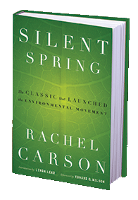
Silent Spring – Summer Poster
Directions:
- Read the BOOK: Silent Spring by Rachel Carson
**The movie can be watched as a supplement but will NOT be enough by itself

- Create a Poster (DUE 9/3/2019)

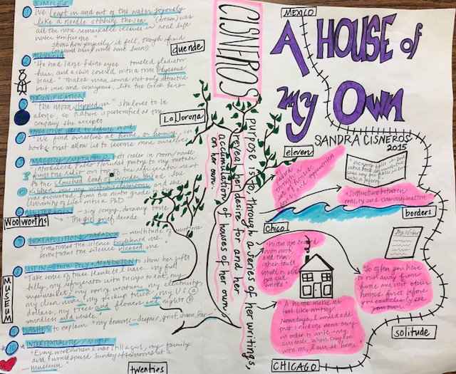
Description: Create a poster based on the book Silent Spring by Rachel Carson
You will be graded on your creativity, attention to detail, as well as the information that you provide.

Requirements:
- Poster Board 22" x 28"
  - Use different types of art supplies for your poster (markers, paint, glitter, colored pencils, etc.).
  - Be creative! It should neat, informative, and interesting
- Requirements:
  - Title of the book must be in large writing and should stand out (sample)
  - Include the author’s name
    - YOUR NAME GOES ON THE BACK
  - A major illustration or collage should be the focus of your poster. It should give the audience a good idea of the setting & a major plot element (significant scene) of the book. DO NOT COPY THE BOOK COVER!
  - Include the FIVE most important/relevant quotes somewhere on your poster
  - Select 6 Big words i.e. “theme words” and BOLD them around the poster
  - Create a “book Spine” in the middle using a Key Phrase/Tag Line
    - Tag Line: interests the audience and describes the basic plot/theme
      - (Example: Shrek used “The greatest fairy tale never told” and Charlotte’s Web used “Help is coming from above”)
  - Within the poster answer the following:
    - Why is this book called “Silent Spring”?
    - What is uniquely problematic about DDT and other chlorinated hydrocarbons?
    - What is Carson referring to when she writes that there is a “human price” for the use of toxins? Why is it so crucial that human beings begin to see themselves as an essential part of the natural world?
    - Her description of chemical spraying suggests that moral dilemmas are involved in the use of toxins as well as technical problems of environmental management. What moral dilemma is Carson worried about?
    - What impact did this book have on the Environmental movement? Explain w/ examples

